Kiama P&C Inc.
MEETING MINUTES
Date: | 28/03/2022
Time: | 6:07pm meeting opened by Cathryn Lyall
Place: | KPS Library

1. WELCOME AND PREVIOUS MINUTES

1.1 Welcome and opening remarks

Executive members were present. Determination of a quorum present to proceed with the meeting was declared and the meeting opened at 6:07pm. CL officially thanked those present and those who are engaging with P&C this year and acknowledged the fantastic support from Natalie and Sarah.

1.2 Acknowledgement of Country

KPS P&C acknowledges the Wadi Wadi people of the Dharawal nation, the Traditional Custodians of the lands on which we live, work and play. We recognise their continuing connection to country: land, water and community, and pay our respects to Elders, past, present and emerging.

1.3 Apologies and welcome to new members

Attendees: | Cathryn Lyall (President, CL), Klaas van Alphen (Treasurer, KV), Bek McAlister (Vice President, RM), Leah McDonald (Vice President, LM), Sarah Webb (Co-Principal, SW), Natalie Marshall (Co-Principal, NM), Nicole O’Brien, Mel Rigby, Darren Fernandes (DF), Caroline Jones (CJ), Fiona Arten (FA)
Apologies: | Kaylene Derix (Secretary, KD), Belinda Meier (BM), Kaye Middleton, Beth Horner, Rachael Peedom, Julie Countee

1.4 Approval of Minutes

Minutes from the previous Meeting were made available on the school website and eNews to all P&C members for verification of accuracy and to facilitate task assignment.

Motion: That the minutes of the previous General Meeting held on 21 Feb 2022 be accepted.
Moved: Bek McAlister Seconded: Mel Rigby

1.5 Matters Arising

No Matters Arising

2. EXECUTIVE REPORTS

2.1 President’s Report

CL Advised though there has been sporadic assistance and incoming support from parents we have a strong core group whose contribution is very valued. CL encouraged all that when they are out talking to KPS parents to put them in touch with the exec to join the P&C and assist. Presently there is a lot to be achieved, and few of us to do it. CL acknowledged the positive culture and great P&C team.K
2.2 Principal’s Report

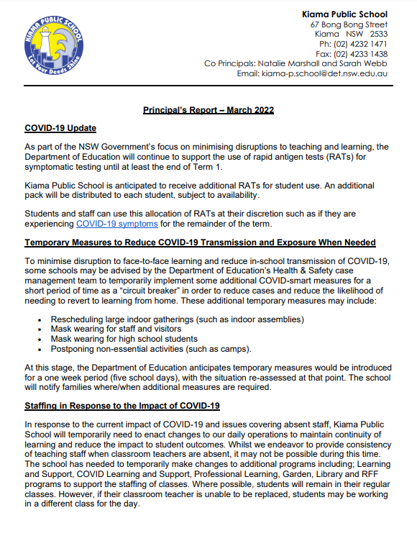
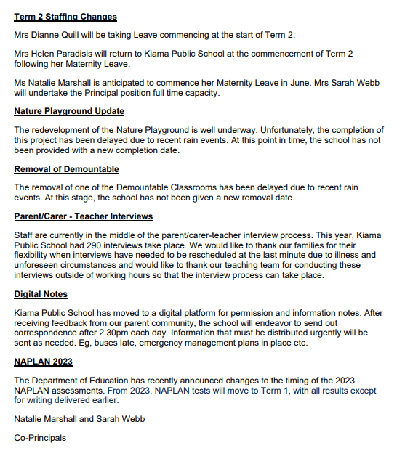
2.3 Treasurer’s Report

KvA informed the committee that there has been limited changes to the financial situation of the P&C since the last meeting.

Work is progress in preparation for the audit of last year’s finances.

2.4 Sub Committees and Representatives

2.4.1 Fundraising and Events

      - KPS Cookbook
All activities to sell cookbooks suggested last meeting have been executed. LM secured a great sale of 15 boxes of cookbooks through a real estate, many other lines are out. A push through the school is coming where parents can sign for books to on-sell through the community.

      - Family Fun Night
- We are now able to have onsite, COLA location as grounds very damp and not tenable for foot traffic. Term 2 date TBD

      - Ellawarra
- Booked for Saturday 21 May at Kiama Leagues.
- Free room hire (saving of $440).
- Drag Performer Ellawarra booked in.
- Call for donations of prizes for silent auction.
- RM to provide letter of thanks to Kiama Leagues Club for room hire donation (actioned).
- Tickets on sale soon $35.
- Suggestion to sell bingo dotters taken on board for consideration.
- Thanks Mel for offering to assist with event.
- Committee will reach out closer to the date.

      - Kindy Activities
- LM reported on successful connection event for new KPS parents with kindy kids. Thanks to Leah and Eva for championing this initiative.

      - Mothers day stall
- All gifts are ordered and at the school
- Stall will be open for kids in Bombo room on 3rd of May
- Market stall has been booked for Wednesday markets on 4th of May

      - Grants
- Flood Disaster grants were discussed to assist with the deterioration of the soft fall areas under the spider web due to significant rain fall and Kiama declared disaster zone.
- SW to provide quote for resurfacing of basketball courts to CL and KvA. Potential grant funding for this could be obtained from Leagues Club.
- Meeting to be set up between Daniel Pride, KvA and CL to discuss P&C grant support for STE(A)M / Tech program.

    - Sponsorships
See discussion on grant funding for court resurfacing above.

2.4.4 Special Support Sub-Committee
CJ Advised that she and Claudia are moving away from the idea of a Homework Club as it is difficult to administer. They are focusing instead on Parent Support group initiative with a date to come soon that P&C and KPS will support with advertising to build attendance. Caroline also raised volunteering in class and SW will discuss with classroom teacher Andrew Elsmore to determine feasibility.

2.4.5 Ethics
DF advised that classes have resumed and there are 5 teachers currently with 5 more needed.

3. Correspondence -
None submitted

4. GENERAL BUSINESS - to be submitted prior to the meeting
Responding to a parent query, NM provided an overview of the roll call process, and subsequent notification to parents if a child is not present.

5. CLOSE AND NEXT MEETING

Close at 19:35

Next Meeting will be Monday 9th May 6pm – 7:30pm (LATER AMENDED TO 23rd May at 6pm)

Minute Taker: | RM
Signed: | Omitted in version submitted for online publication
Name: | Rebecca McAlister
Date: | 21/02/2022

