Kiama P&C Inc.
MEETING MINUTES
Date: | 13/09/2021
Time: | 6:00pm meeting opened by Cathryn Lyall
Place: | Via Zoom

1. WELCOME AND PREVIOUS MINUTES

1.1 Welcome and opening remarks

Executive members were present. Determination of a quorum present to proceed with the meeting was declared and the meeting opened at 6:04pm. CL officially welcomed all in attendance.

1.2 Acknowledgement of Country

KPS P & C acknowledges the Wadi Wadi people of the Dharawal nation, the Traditional Custodians of the lands on which we live, work and play. We recognise their continuing connection to country: land, water and community, and pay our respects to Elders, past, present and emerging.

1.3 Apologies and welcome to new members

Attendees: | Cathryn Lyall (President, CL), Klaas van Alphen (Treasurer, KV), Kaylene Derix (Secretary, KD), Bek McAlister (Vice President, BM), Leah MacDonald (Vice President, LM), Natalie Marshall (Principal, NM), Sarah Webb (Co-Principal, SW), Sheree Payne (SP), Melinda Prior (MP), Tanya Kruger (TK), Belinda Meier (BM), Mark Wolstenholme (MW), Emma Kate Dewhurst (ED), Julie McKenzie (JM)
Apologies: | Rachel Peedom, Emily Crump, Melissa Kirk (MK), Tash Ross (TR), Beth Horner,  Caroline Jones, Kaye Middleton, Claudia

1.4 Approval of Minutes

Minutes from the previous Meeting were made available on the school website and eNews to all P&C members for verification of accuracy and to facilitate task assignment.

Motion: That the minutes of the previous General Meeting held on 2 August 2021 be accepted.

Moved: Mark Wolstenhome Seconded: Leah McDonald

1.5 Matters Arising

No Matters Arising

2. EXECUTIVE REPORTS

2.1 President’s Report

The P&C Executive are meeting regularly as possible. It is sad not to be able to hold any of the planned events. School happy to do a wear red day to support Willow Porter, thank you to the school for the quick turnaround. All events from Term 4 prioritized to 2022. Instagram account to go live soon so we have another form of communication with the parents. CL welcomed Leah MacDonald to the Executive Committee. Ethics role is still not filled.

2.2 Principal’s Report

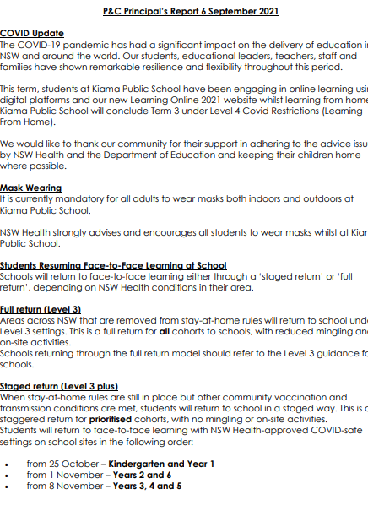
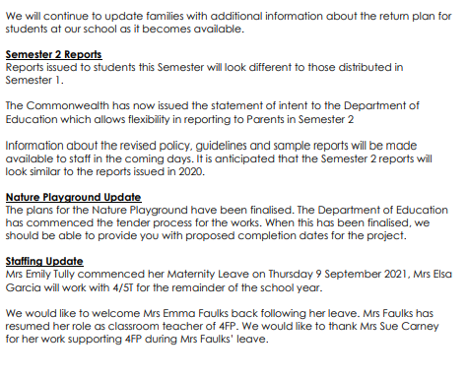

2.3 Treasurer’s Report

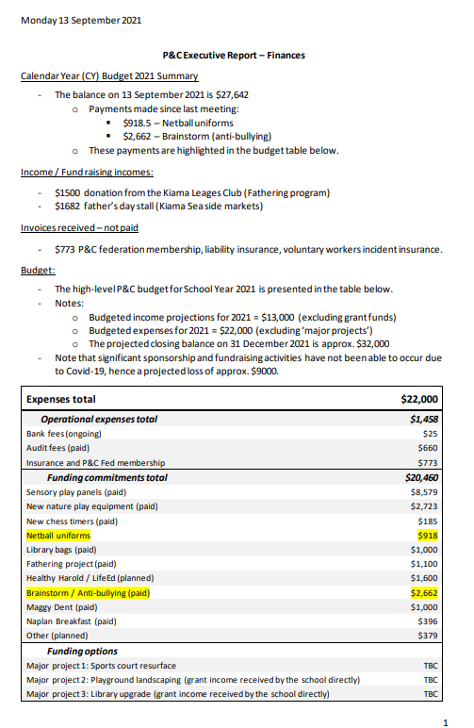

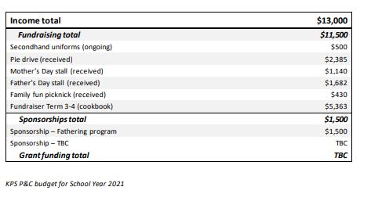
2.4 Sub Committees and Representatives

2.4.1 Fundraising

      - Kiama PS Cookbook
- Waiting on school recipes to be submitted – Sharee Payne has plenty from stage 3.
- BM to post on social media
- Stage 1&2 send out as Passion Project
- Call out to Parents, Shaye happy to help
- CL/KD/LM committee will speak to businesses regarding sponsorship and discuss options for sales.
- Close moved to end school holidays, ready for Term 4 sales.

      - Colour Run
- To be held Term 2, 2022 when it is not as hot.
      - Father’s Day Stall
- Held at Farmers Markets
- Sale went well, plenty of customers, sold more than 50% stock
- Market Managers happy to make this annual
- Could buy Aprons etc. to sell with the Cookbooks.
      - Parents Fundraiser – Ellawarra drag Bingo 22 October 2021
- Postponed to April, depending on Easter dates.
      - Family Fun Night
- Book dated end Term 1 2022

      - Kiama Seaside Markets
- BBQ dates to be confirmed
      - Fundraising – Belinda Meier
- Suggested Jolly Socks fundraiser, socks cost $3.30each
- BM to look into

2.4.2 Grants

No grant update from KV
NM mention basketball court upgrade, Greg Smith given cost of court resurface $25K, Basketball and netball rings $7-8K, total around 40K for complete works. Need to separate from the school and make P&C project so school can run not Education Department.
Klaas will look for grants.

2.4.3 Sponsorships

N/A

2.4.4 Traffic safety Subcommittee

- Mark update
- MW working on draft to council
- Council, road safety officer requested meeting with MW in regards to spending 100K grant.
- CL thanked MW for all his work, need to sit with NM and SW to discuss priorities for school.
- Meet Term 4, nothing locked in. P&C to meet with NM and SW first
- MW left meeting at 6:39

2.4.4 Special Support Sub-Committee

- Caroline Jones & Claudia unavailable, report at next meeting

3. Correspondence - nil.

4. GENERAL BUSINESS - to be submitted prior to the meeting

No general business.

5. CLOSE AND NEXT MEETING

Close at 19:20

Next Meeting will be 18 October 2021

Minute Taker | KD
Signed: | Omitted in version submitted for online publication
Name: | Kaylene Derix
Date: | 12/10/2021

